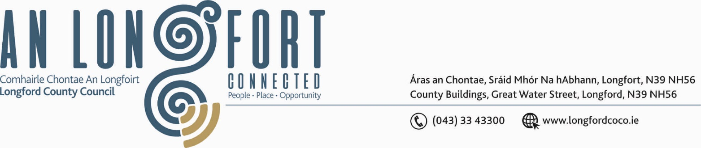

LONGFORD MUNICIPAL DISTRICT

Please Note Venue for Meeting – Aras an Chontae.

17th October 2019.

To: Each Member of Longford Municipal District.

Dear Member,

You are requested to attend Meeting of Longford Municipal District to be held in the Council Chamber, Aras an Chontae, Great Water Street, Longford, on Wednesday, 23rd October 2019 at 4.30 p.m. to transact business, as set out on the Agenda hereunder.

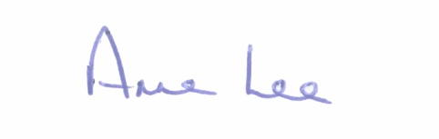
Yours sincerely,

_______________
Anne Lee,
Meetings Administrator.

AGENDA

Prayer before meeting.

- Confirmation of Minutes of Longford Municipal District Meeting held on the
25th September 2019 – copy enclosed.

- Matters arising from Minutes.

- Declaration of Interest by Members.

- Management Report - To Follow.

- Consideration of the 2020 General Municipal Allocation.

- Consideration of Free Parking arrangements during Christmas period.

- Confirmation of Longford Town CCTV Camera positions under Data Protection Legislation.

- Notices of Motions, submitted by Councillors, as listed hereunder -

Councillor Gerry Warnock.

“I am calling on Longford County Council Housing Department to initiate a Regeneration Programme targeting the reconditioning and bringing back into use of vacant properties in some of the oldest residential areas of Longford Town – namely Wards Terrace/O’Connell Terrace, Convent Road and Great Water Street. I am proposing that once completed, the refurbished units be piloted as an Affordable Housing Scheme targeted at young, working families to assist them to get onto the property ladder. The project should include the following works:

- Identify funding under the Rebuilding Ireland Programme to recondition voids in Council ownership at said locations
- Initiate Compulsory Purchase Order (CPO) proceedings against Property Owners of abandoned/derelict properties at said locations
- Retain the traditional fabric of the both locations through appropriate planning and design works
- Specific campaign to source appropriate expressions of interest from qualifying local applicants

A pilot project such as this could have multifaceted benefits in terms of affording young families an opportunity to get on the property ladder, revival and regeneration of our urban core, and retention of local heritage through rebuilding communities in some of the oldest parts of town. This project might be a gentle foray into exploring Affordable Housing options for Longford in lieu of a more substantial Serviced Sites or Specific Build Schemes.”

Councillor John Browne

“ I call on Longford County Council to put a path up to Mulleady’s Factory and Recycling Plant at Cloonaugh , as a matter of urgency, where over 100 people are employed.
The path would leave it much safer for employees to go to work, similar to the pathway at Kiernan Milling Granard”

Councillor Martin Monaghan

“I call on Longford county Council to address the Serious safety concerns I have regarding lack of lighting at Longford Retail Park , overall upkeep of existing units and communal areas and condition of existing car park therein”

- A.O.B.



